LABORATORY # 05

Basic Filters and Frequency Response

Purpose
The goal of this laboratory is to study the frequency characteristics of Low and High Pass Filters. Specifically, signal amplitude, signal phase, and how they are related to input frequency will be explored. In addition, the concept of cutoff frequency will be introduced.

Theoretical Background
A filter is a device or configuration that allows a specific range of input frequencies to pass and rejects signals whose frequency is outside of the specified range. Among the many types of filters, in this laboratory you will be introduced to basic Low and High Pass Filters. These filters consist of nothing more than a configuration made up of a single resistor and capacitor.

Low Pass Filter
Low Pass Filters allow low frequencies to pass and block high frequencies. The ideal Low Pass Filter should allow all frequencies below some specified frequency, call it fc, to pass and allow no frequencies above fc to pass. It is not possible to design an ideal Low Pass Filter. Therefore the design characteristics of the filters used in this laboratory will be non-ideal. It is important to be aware there are more sophisticated filtering devices on the market that approach the ideal case.

Figure 5.1, on the next page, shows a typical configuration for a Low Pass Filter. Through the mathematical development to follow it will be shown that the circuit is acting as a Low Pass Filter at the output terminal A-B. The input frequency and amplitude of E, will directly influence the magnitude and phase of Vc. In other words, at certain input frequencies the Low Pass Filter will operate on the input E to produce Vc. The frequency where this action occurs is determined by values chosen for the resistor (R) and the capacitor (C).
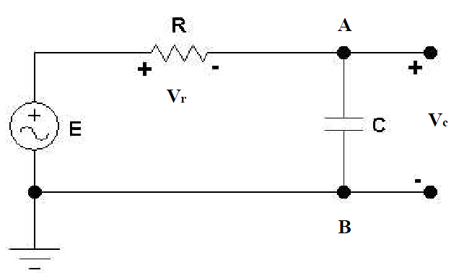

Figure 5.1

The voltage across the capacitor in Figure 5.1 can be written as
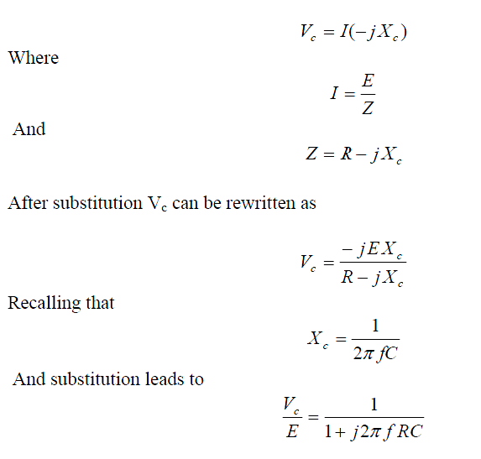

If we use the definition of gain, and take the magnitude, the final form can be written as

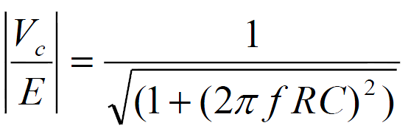

From inspection of Equation 11.1 it is apparent that as the frequency (f) increases, the magnitude of the gain decreases. In short, the circuit in Figure 11.1 works as a Low Pass Filter. Also take note that the product RC has an effect on the overall gain. The phase angle for the Low Pass Filter can be expressed as

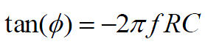

Note that the phase is initially at zero radians, where ideal gain is at its maximum. This shows that the phase of the output will approach -π/2 radians as the frequency increases.

High Pass Filter

High Pass Filters allow high frequencies to pass and block low frequencies. The ideal High Pass Filter should allow all frequencies above some specified frequency, call it fc, to pass and allow no frequencies below fc to pass. It will be shown mathematically that the circuit is acting as a High Pass Filter at the output terminal A-B, in Figure 5.2.

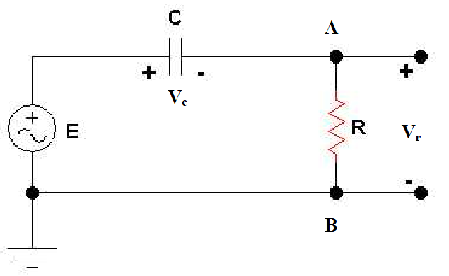
Figure 5.2

The voltage across the resistor, in Figure 5.2, can be written as

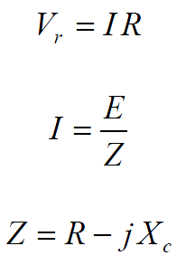

Using the definition of Xc, and making substitutions, allows the equation to be rewritten as

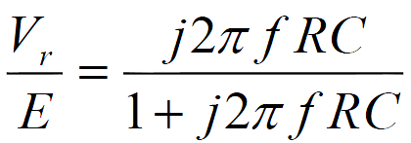

Using the definition of gain and taking the magnitude gives the final form of

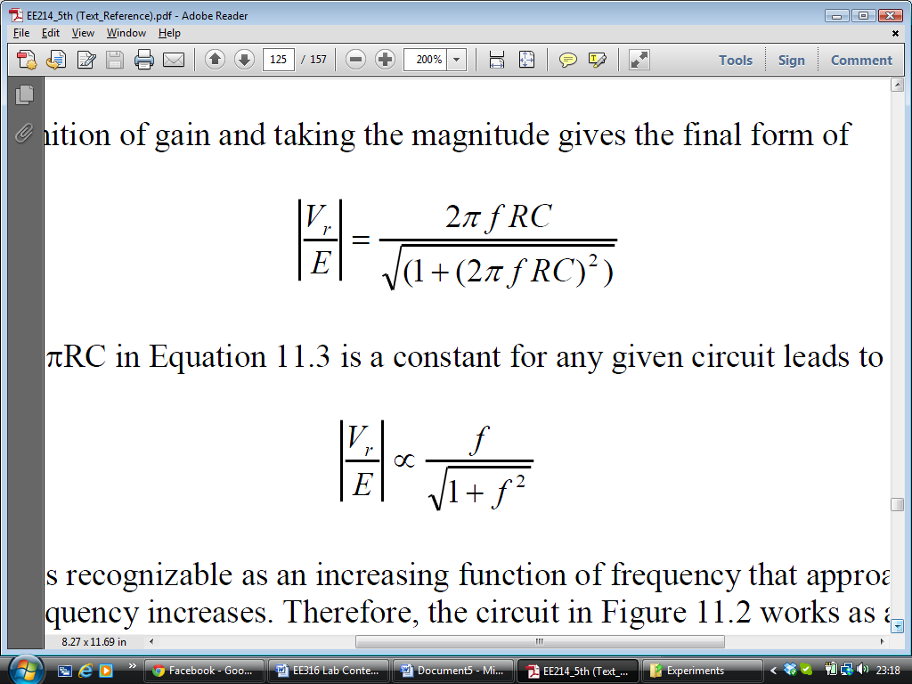

Noticing that 2RC in above Equation is a constant for any given circuit leads to

This equation is recognizable as an increasing function of frequency that approaches unity as the frequency increases. Therefore, the circuit in Figure 5.2 works as a High Pass Filter. The phase angle for the High Pass Filter can be expressed as

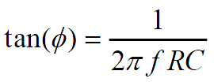

Note the phase is initially at π/2 radians, where ideal gain is zero. It shows that the phase of the output will approach zero radians as the frequency increases.

Cutoff Frequency

The cutoff frequency, denoted by fc, is defined as the frequency at which the magnitude of gain is equal to
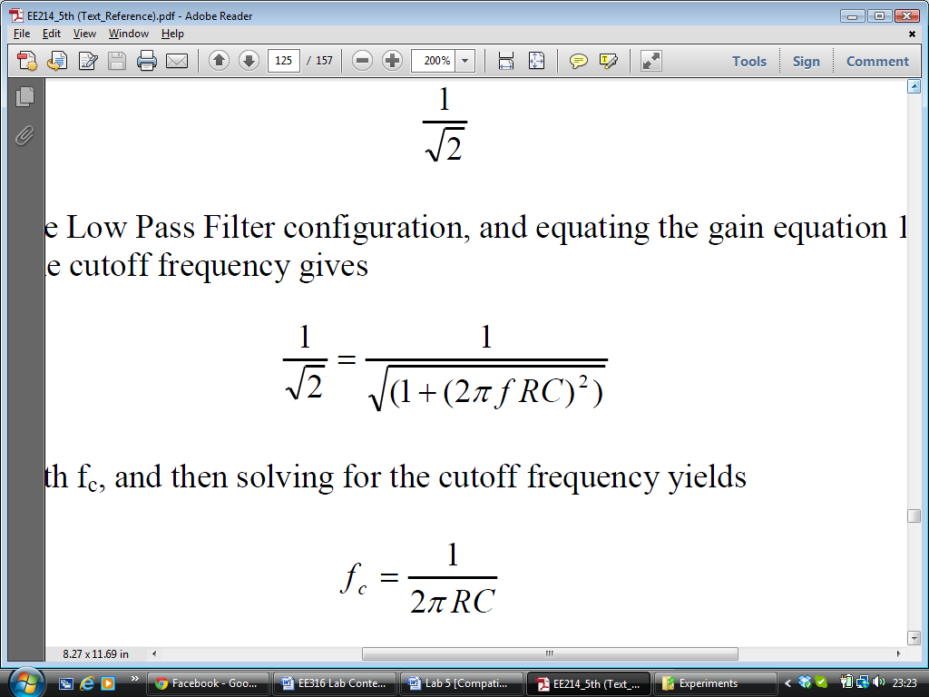

Considering the Low Pass Filter configuration

Replacing f with fc, and then solving for the cutoff frequency yields

This is true for both Low and High Pass Filters. You determine the cutoff frequency by setting the product value of (RC). Keeping in mind that a low pass configuration will pass frequencies below fc and the high pass configuration will pass frequencies above fc.

Theoretical Analysis

Let the input signal be E(t) = 42 cos(t), with = 2f, R = 1 K, and C = 1uF for both the Low and High Pass Filter sections. Note E = 4. You will need this below.

Low Pass Filter

Use the circuit in Figure 5.1 for steps 1 through 4.

- Fill up a table similar to the one given below. (Table 5.1).
- Plot Gain Magnitude vs. frequency. Use data from Table 5.1.
- Plot Phase vs. frequency. Use data from Table 5.1.

Table 5.1

f (HZ) | Gain Magnitude | Phase Angle (Degree)
25
50
75
100
150
200
250
300
400
500
600
800
1000

High Pass Filter

Use the circuit in Figure 5.2 for steps 1 through 4.

- Fill up a table similar to the one given below. (Table 5.2).
- Plot Gain Magnitude vs. frequency. Use data from Table 5.2.
- Plot Phase vs. frequency. Use data from Table 5.2.

Table 5.2

f (HZ) | Gain Magnitude | Phase Angle (Degree)
25
50
75
100
150
200
250
300
400
500
600
800
1000

Simulation

Low Pass Filter
Draw the circuit similar to Figure 5.3 on the next page. Note the connection of a new instrument. This instrument is called a Bode Plotter. The Bode Plotter produces a graph of a circuit's frequency response. It is capable of measuring a signal's voltage gain and phase shift. Both gain and phase are plotted against frequency on the screen. The vertical and horizontal scales, F and I, should be preset to display the area of interest on the Bode screen.
For the simulation section let your input signal be defined as e(t) = 4√2 cos(wt),
where = 2f, f = 100 HZ, R = 1 K, and C = 1uF.

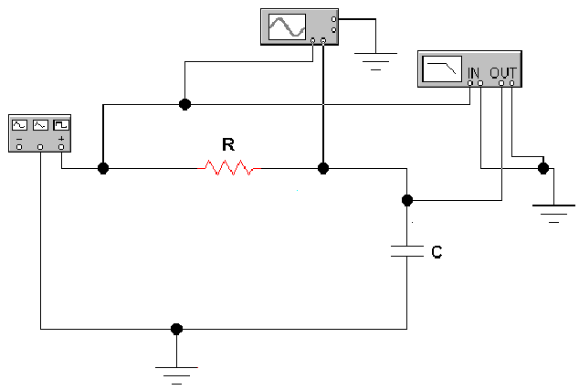
Figure 5.3

- Open the Bode Plotter. Set the plotter for a magnitude reading by depressing the Magnitude button. Then depress Linear (Lin) buttons under both the Vertical and Horizontal headings. Next Set I = 0 and F = 1 under the Vertical heading, and I = 1 Hz and F = 2 kHz under the Horizontal heading. See Figure 5.4 below.
- Set up your function generator with the defined inputs and simulate the circuit. Make a printout of the Bode Plotter output. Interpret the output of the plot. Does it show Low Pass or High Pass Filter characteristics?
- Determine the cutoff frequency by moving the cursor line. Position the cursor line by clicking on the left and right arrows. The cursor position is displayed in the windows next to the arrows. Recall the cutoff frequency occurs when the output magnitude is 0.707, the magnitude of the input. Make a print of the output with the cursor line positioned at the cutoff frequency on the screen.
- Make the necessary changes in settings on the Bode Plotter in order to get Phase characteristic. Depress the Phase button. Then simulate the circuit and make a printout of the output.

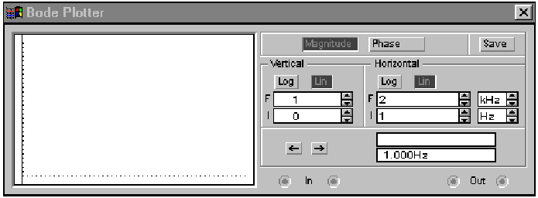
Figure 5.4

High Pass Filter
Use the same circuit as in Figure 5.3 but switch the positions of R and C to convert the circuit into a High Pass Filter configuration. Use the same values from the Low Pass Filter simulation for your input and circuit parameters. Repeat steps 1 through 3 from Low Pass Filter simulation. However, you will need to reset the Bode Plotter settings to get the magnitude and phase characteristics for the High Pass Filter. Turn the circuit on and adjust F and I for both the Vertical and Horizontal settings. Once you have a viewable output, stop the simulation. Now restart the simulation and take your data.

Laboratory Procedure
Build both a Low Pass Filter (Figure 5.1) and a High Pass Filter (Figure 5.2) in the laboratory. You should use the Oscilloscope and Multimeter to make your measurements. Follow all the steps from the Theoretical Analysis.

Simulation Results

